1)

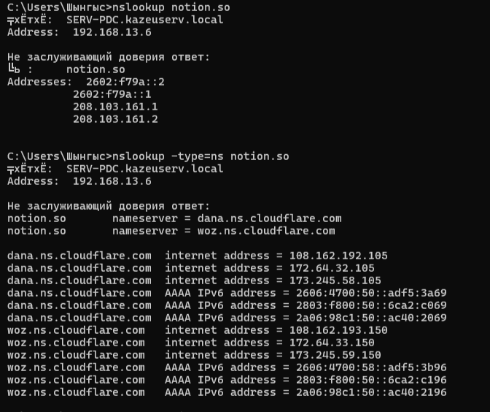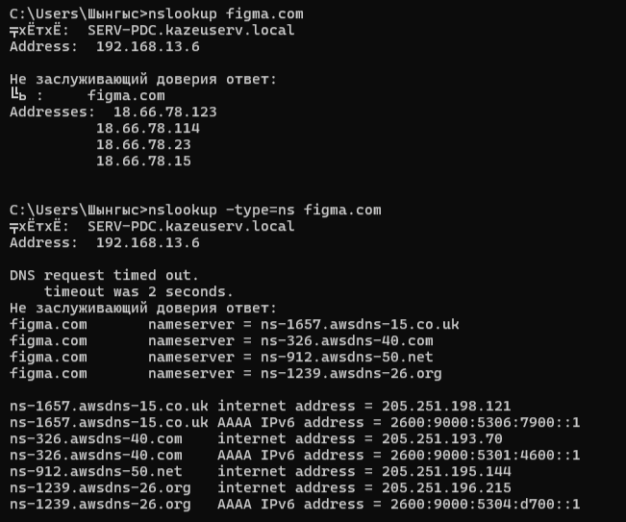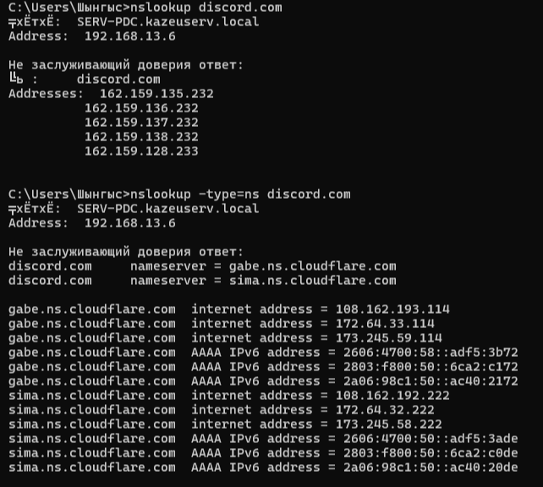

DNS REPORT
1. notion.so
A Records:
208.103.161.1
208.103.161.2
TTL: 61 seconds
Authoritative Nameservers:
dana.ns.cloudflare.com
woz.ns.cloudflare.com
Comment:
The TTL is 61 seconds, which is pretty short. I think Notion uses a low TTL so DNS changes can update quickly and users can be redirected to different servers if needed.

2. figma.com
A Records:
3.164.68.108
3.164.68.56
3.164.68.19
3.164.68.26
TTL: 59 seconds
Authoritative Nameservers:
ns-1657.awsdns-15.co.uk
ns-326.awsdns-40.com
ns-912.awsdns-50.net
ns-1239.awsdns-26.org
Comment:
The TTL is only 59 seconds. My guess is that Figma uses a short TTL because it has many users and may need to balance traffic between different servers.

3. discord.com
A Records:
162.159.135.232
162.159.136.232
162.159.137.232
162.159.138.232
162.159.128.233
TTL: 111 seconds
Authoritative Nameservers:
gabe.ns.cloudflare.com
sima.ns.cloudflare.com
Comment:
Discord also has a relatively short TTL. I think this helps them manage a large amount of traffic and make DNS updates faster when necessary.

2)
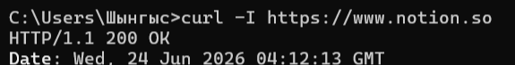

Status Code 200
Command:
curl -I https://www.notion.so
Status code received:
HTTP/1.1 200 OK

Status Code 404
Command:
curl -I https://httpbin.org/status/404
Status code received:
HTTP/1.1 404 NOT FOUND

3)
I used the Figma website and inspected its network activity using Chrome DevTools.
617e0bc399c83bea.css (CSS file)
This file is used for the visual appearance of the website, including layout, colors, fonts, and other styling elements.
oaiq.min.js (JavaScript file)
This script provides functionality and interactivity on the page. It helps the website respond to user actions and load dynamic content.
7c42ed55a7834032-s.p.woff2 (Font file)
This file contains a web font used by the website. It ensures that text is displayed with the correct typography across different devices and browsers.

